**DOS Project 4 Part I**

Group Members:

Chandan Chowdary (UFID-6972-9002)

Gayathri Manogna Isireddy (UFID-9124-0699)

Project Description:

The goal of this project is to implement a Twitter Clone. We will be implementing a twitter like engine and this engine will be paired up with web sockets to provide full functionality in part 2.

Part 1, which is twitter like engine is implemented with following functionalities-

* Register account
* Send tweet. Tweets can have hashtags (e.g. #COP5615isgreat) and mentions (@bestuser)
* Subscribe to user's tweets
* Re-tweets (so that your subscribers get an interesting tweet you got by other means)
* Allow querying tweets subscribed to, tweets with specific hashtags, tweets in which the user is mentioned (my mentions)
* If the user is connected, deliver the above types of tweets live (without querying)

Also, implemented test cases with EXUNIT to test these functionalities.

Architecture-

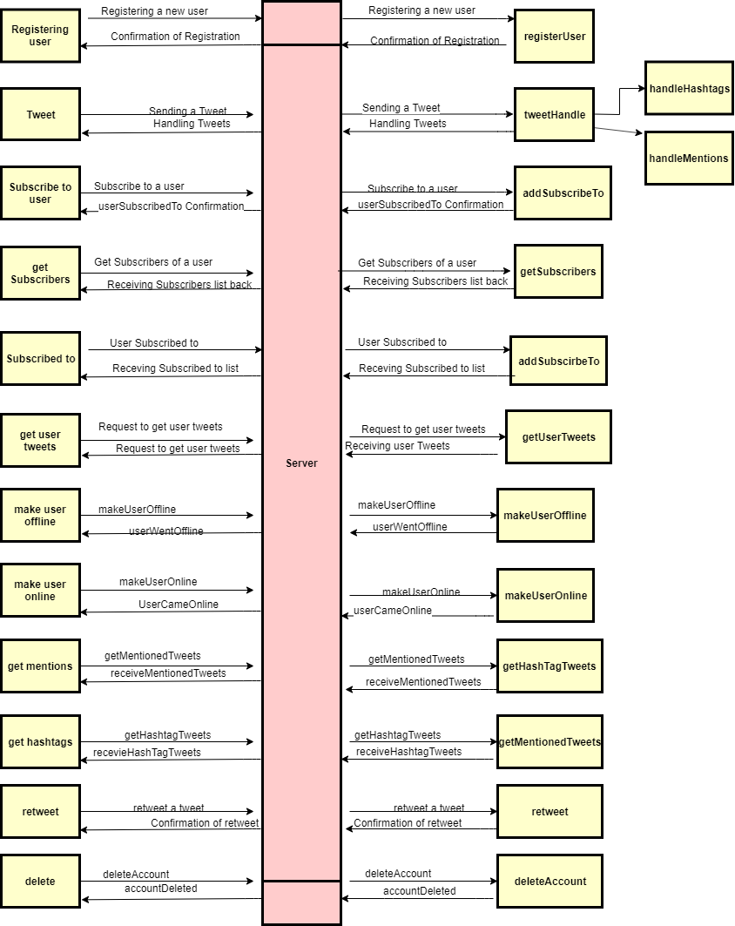

Implementation Details-

Proj4.ex: This elixir file is the starting point and contains the main method. Our implementation takes 2 parameters in the order – num_user, num_msg

* num_user: number of users to simulate (eg.10 )
* num_msg: Number of tweets each user can tweet.(eg.2)

Server.ex: In this file twitter server engine code is implemented. ETS tables are used for database implementation. This engine is responsible for registering user, processing tweets and distributing tweets. Engine directly communicates with the database.

Client.ex: This file consists of user related information like creating user actors which includes the information of its user id which is a numeric string (“user 1”). Also, automation process is implemented here.

**Performance Results**:

1. Average Time to register user (microseconds)

2. Average time taken by the user to tweet (microseconds)

3. Average time taken to get tweets with a specific hashtag (microseconds)

4. Average time taken to get mentioned tweets (microseconds)

5. Average time taken to get tweets of user (microseconds)

6. Average time taken to subscribe to an user (micsroseconds)

7. Average time taken to get subscribers of user (microseconds)

8. Average time taken to get the users that an user has subscribed to (microseconds)

9. Average time taken to retweet (microseconds)

|  |  |  |  |  |  |  |  |  |  |  |
| --- | --- | --- | --- | --- | --- | --- | --- | --- | --- | --- |
| Number of Clients | Number of Tweets | 1. | 2. | 3. | 4. | 5. | 6. | 7. | 8. | 9. |
| 10 | 1 | 167.2 | 233.834 | 375.0 | 176.0 | 312.5 | 867.0 | 288.8 | 282.4 | 0 |
| 50 | 10 | 320.0 | 313.725 | 3041.096 | 31000 | 2285.714 | 40082.474 | 37872.340 | 37219.512 | 900.0 |
| 100 | 5 | 150.0 | 297.030 | 2065.359 | 47000 | 2259.740 | 90905.087 | 46413.334 | 44025.641 | 1719.101 |
| 500 | 2 | 780.0 | 808.383 | 2092.807 | 0 | 2551.111 | 86039.418 | 163733.644 | 170074.699 | 3895.833 |
| 1000 |  |  |  |  |  |  |  |  |  |  |